WEB DEVELOPMENT 5020

WHOLENESS FITNESS ATHLEISURE PROPOSAL

Wanga Stuurman

ST10488602

Table of Contents

Wholeness Fitness Athleisure 2

History 2

Mission 2

Vision 2

Website goals and objectives 3

Current website analysis 3

Proposed website features and functionality 3

Design and user experience 4

Technical requirements 4

Timeline and milestones 5

Budget 5

References 7

# Wholeness Fitness Athleisure

## History

With increase in activity surrounding fitness, comfortable athleisure became a need – a need Wholeness Fitness Athleisure could satisfy by working hard towards fulfilling our vision and achieving our mission. That became a driving force for creating comfortable, fashionable, sustainable, and functional fitness wear.

What started out as a small business in 2014 expanded to owning three stores and being available in seven stores around the country. Showing that the business can cater to diverse people whether they are athletes, fitness enthusiasts, or are simply people with a value for comfortable stylishness in their daily lives. With increase in demand, we set out to continue creating a brand that redefines athleisure and continues giving people high-performing and fashionable wear that can be everyday wear.

## Mission

* Encourage people to reach their exercise objectives while feeling secure and at ease in their clothes.
* Make sure the brand stays alive, energised, relevant, and at the forefront of its industry through constant evolution.
* Promote and confidence in individual uniqueness.
* Assure long-term steady growth and sustainability.

## Vision

Be a top brand that creates athleisure wear that is:

* Sustainable
* Fashionable
* Functional

Target audience is the people, all people.

## Website goals and objectives

* Advertise products – this means there will be images showing the products sold by the business.
* Provide valuable information – in the about us page history and what the business is about will be shown and ways to contact the business will be provided.
* Increase brand awareness – a website means more coverage globally as anyone anywhere will be able to access it and look at it.
* Reach a larger market – a website is available everywhere on the internet.
* Increase sales – the website will show what the business is about and show the products thus increasing the customer visitations in-store.

Key performance indicators: website traffic, average time on page, returning visitors, conversion rate, traffic source, and click-through rate.

## Current website analysis

The website is for a new business

Strengths: good information coverage, clear history and basic information, provided contacts details, there is an enquiry form should customers want to enquire.

Weaknesses: no online shopping only viewing of products.

It might need its own online ordering system and maybe include an add to cart icon.

## Proposed website features and functionality

* Homepage – users can expect a page welcoming them and allowing them to access the other pages through hyperlinks.
* About us page – it will provide users with the business’s history and what the business offers.
* Contacts page – users will be able to get the businesses contact details.
* Enquiry page – users will be able to contact the business and enquire.
* Products page – users can expect images of the products available to see what the business offers.

Users must be able to easily move from one webpage to another, do any desired goal if provided, and get feedback when enquired. The user must also receive the needed information about the business should they want to.

## Design and user experience

**Colour scheme**: teal, grey and white

**Typography**: clear bold font and order of information depends on the page a person is visiting, however it will generally start with more important and in demand information.

**Layout and design**: hyperlink to other pages will remain at the top of all pages. The pages will be put in order and the products page will be one instead of also being available in the homepage. The colours in the colour scheme will be shown in a balanced with teal as a background colour. There will be images used to show the products and some to further explain the information.

## Technical requirements

* HTML – for building the structure of the webpages.
* CSS – for adding style to the webpages.
* JAVASCRIPT – for enhancing the overall functioning of the webpages and making it interactive.
* VISUAL STUDIO CODE – for writing the code, checking for errors, and running the code.
* BROWSER – for opening and viewing the website.

## Timeline and milestones

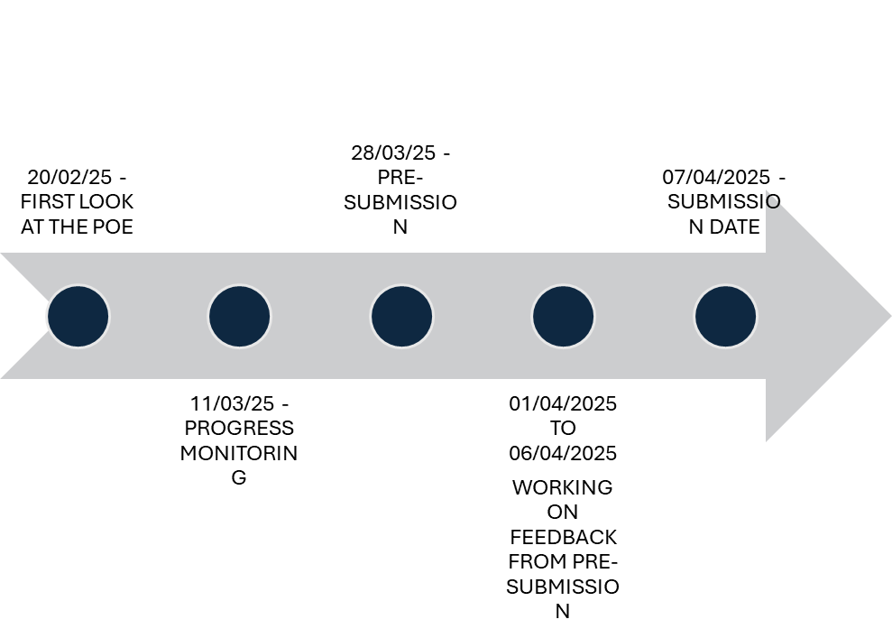

The time given for the assessment was enough, each section did not take longer than the proposed duration.

## Budget

|  |  |
| --- | --- |
| CATEGORY | ESTIMATED COST |
| Development | Template – R0  SEO – R3000  Social media – R1500  Total= R4500 |
| Hosting (Annual) | Domain – R300  Hosting – R3000  SSL certificate – R0  Total= R3300 |
| Maintenance (Annual) | Updates – R2000  Security monitoring - R1000  Backups – R1500  Total= R4500 |
| Total (for one year) | R12300 |

## References

**References for the images used in the website.**

Bamboo ave. 2024. *Athletic Male in Stylish Activewear on Rooftop*. [electronic print]. Available at: <<https://www.pexels.com/photo/athletic-male-in-stylish-activewear-on-rooftop-29205185/> > [Accessed 13 March 2025].

Bamboo ave. 2024. *Athletic Man Posing on Austin Rooftop*. [electronic print]. Available at: <<https://www.pexels.com/photo/athletic-man-posing-on-austin-rooftop-29205122/> > [Accessed 13 March 2025].

Bamboo ave. 2024. *Athletic Man Walking on Rooftop in Austin*. [electronic print]. Available at : <<https://www.pexels.com/photo/athletic-man-walking-on-rooftop-in-austin-29205093/>> [Accessed 13 March 2025].

Bamboo ave. 2023. *Model in an Emerald Green Tank Top and Yoga Shorts Posing on a White Background*. [electronic print]. Available at: <<https://www.pexels.com/photo/model-in-an-emerald-green-tank-top-and-yoga-shorts-posing-on-a-white-background-17917224/> >[(Accessed 13 March 2025].

Bamboo ave. 2023. *Model Posing in Sportswear*. [electronic print]. Available at: <<https://www.pexels.com/photo/model-posing-in-sportswear-17917199/>> [Accessed 13 March 2025].

Bamboo ave. 2023. *Models in Emerald Green Tank Tops and Yoga Shorts from Bamboo ave*. [electronic print]. Available at:< <https://www.pexels.com/photo/models-in-emerald-green-tank-tops-and-yoga-shorts-from-bamboo-ave-17917231/>> [Accessed 13 March 2025].

Kim, S. 2021. *Photo of Women Wearing Activewear Clothes*. [electronic print]. Available at: <<https://www.pexels.com/photo/photo-of-women-wearing-activewear-clothes-8483394/>> [Accessed 13 March 2025].

KoolShooters. 2021. *Woman in Sports Bra and Black Shorts*. [electronic print]. Available at: <<https://www.pexels.com/photo/woman-in-sports-bra-and-black-shorts-8520537/>> [Accessed 13 March 2025].

Mizuno, K. 2022. *Women with Bottles Walking*. [electronic print]. Available at: <<https://www.pexels.com/photo/women-with-bottles-walking-13740414/>> [Accessed 13 March 2025].

RDNE Stock Project. 2021. *Woman in Blue Activewear Doing Stretching Exercise*. [electronic print]. Available at:< <https://www.pexels.com/photo/woman-in-blue-activewear-doing-stretching-exercise-7240207/>> [Accessed 13 March 2025].